NRCAN PPP Script:

_____________________________________________________________

Some helpful hints on running the NRCAN PPP Script

Author: Khal Feen ([k.a@unb.ca](mailto:k.a@unb.ca))

_____________________________________________________________

Run cmd in directory holding the NRCAN script to view commands:

python csrs_ppp_cgi_browser.py –h

**When running on Windows, you may need to install the following programs:**

Wget

Download: http://downloads.sourceforge.net/gnuwin32/wget-1.11.4-1-setup.exe

or http://gnuwin32.sourceforge.net/packages/wget.htm for more options

add wget.exe to path: C:\Program Files (x86)\GnuWin32\bin

unzip

download: http://stahlworks.com/dev/index.php?tool=zipunzip

add to program files manually (ie. Create folder C:\Program Files (x86)\Unzip and put unzip.exe inside)

add to path

**To add path in windows:**

Press windows key + Pause/Break -> windows system window will open

Press “advanced system settings” on left -> system properties will open

Under Advanced press “Environment Variables…” on bottom right

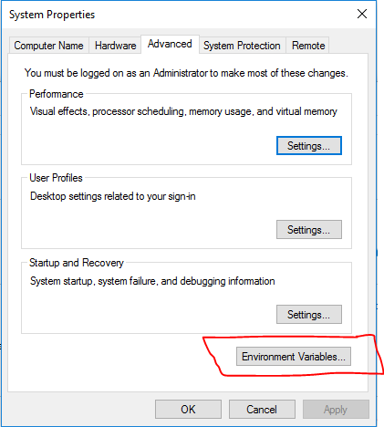

In the bottom box, select “Path” and click Edit

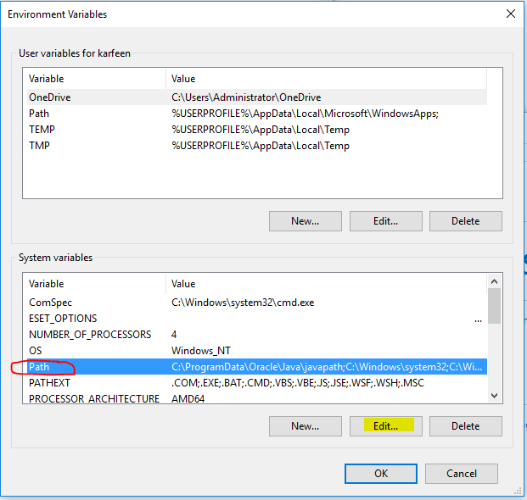

Add folders containing the .exe files you would like on path.

For example:

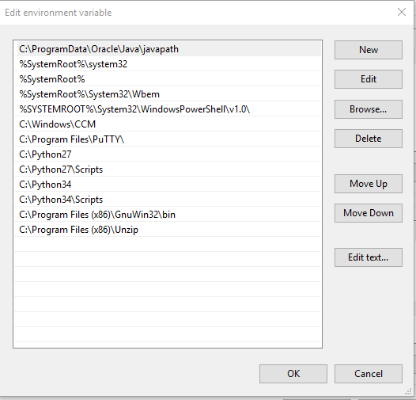

Other troubleshooting:

code fixes:

if timing out in wget, increase this variable:

wget_max = 30 (increase if needed)

if this line is giving an error, enable shell to view windows error

log = Popen(shlex.split(command), stdout=PIPE, shell=True) #add shell

note: cmd needs to be restarted in you installed unzip or wget in session.